Nama : Aditya Rahman Syach

NIM : 1247050069

MK : Algoritma dan Pemrograman

SOAL 1

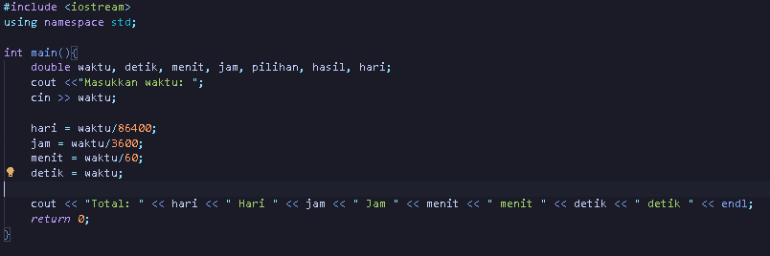

OUTPUT



SOAL 2

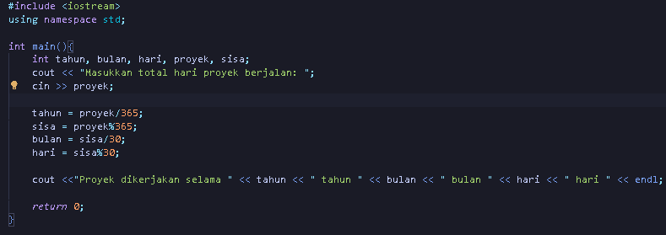

OUTPUT



SOAL 3

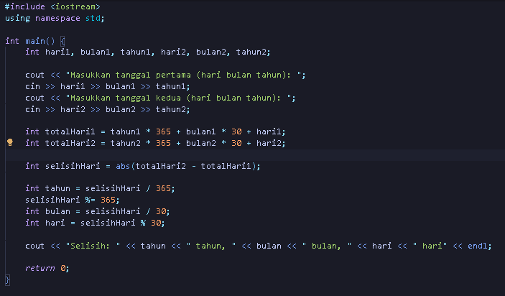

OUTPUT



SOAL 4

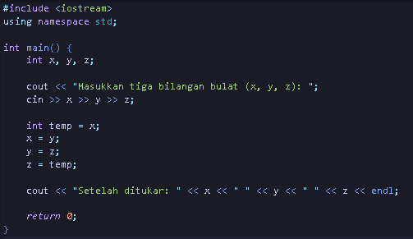

OUTPUT



SOAL 5

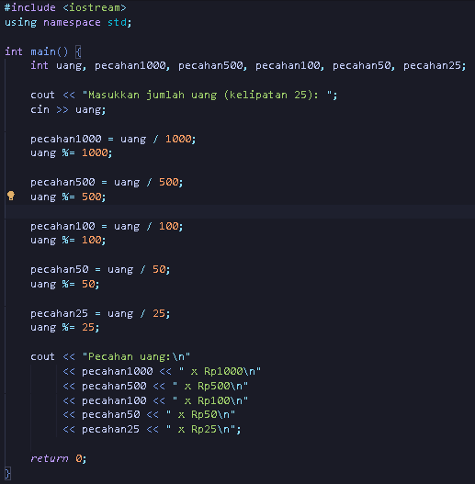

OUTPUT

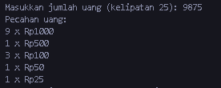

SOAL 6

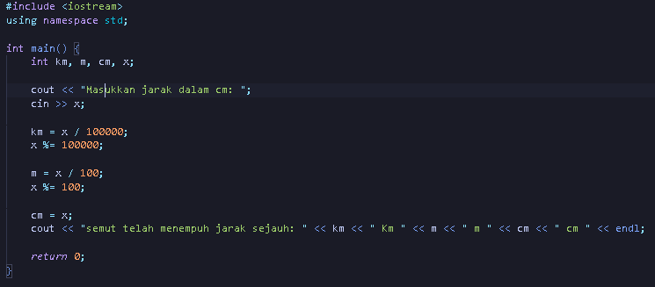

OUTPUT



SOAL 7

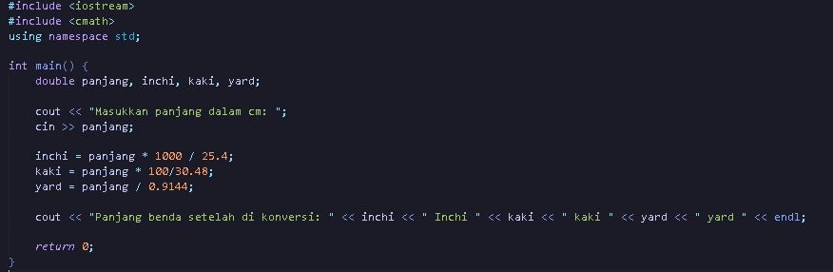

OUTPUT



SOAL 8

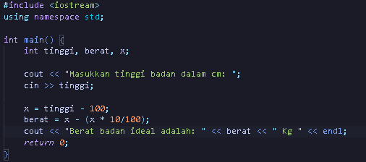

OUTPUT



SOAL 9

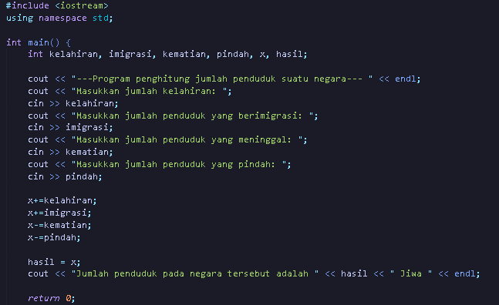

OUTPUT

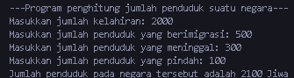

SOAL 6.1

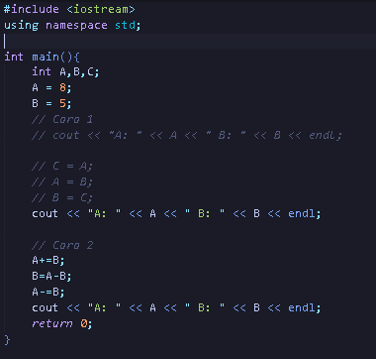

Output:



Soal 6.2

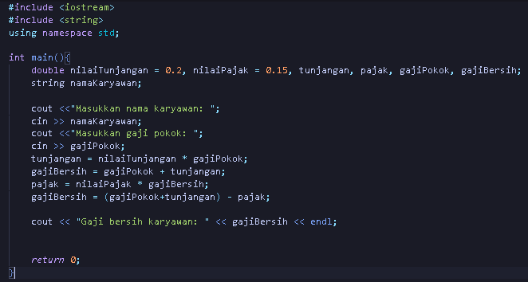

Output:



Soal 6.3

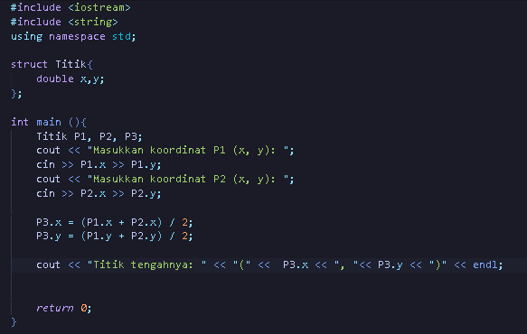

Output:



Soal 6.4

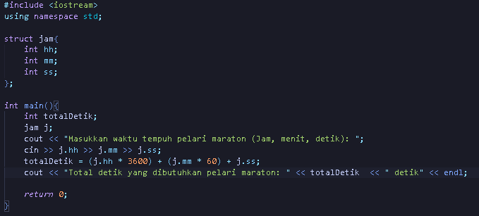

Output:



Soal 6.5

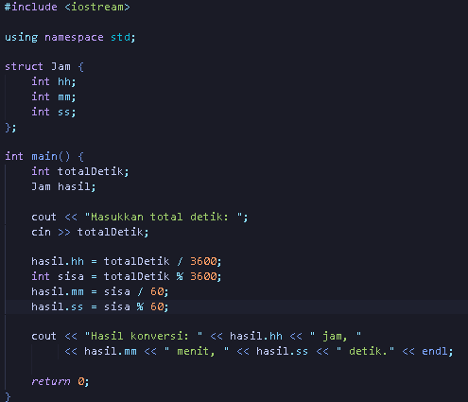

Output:



Soal 6.6

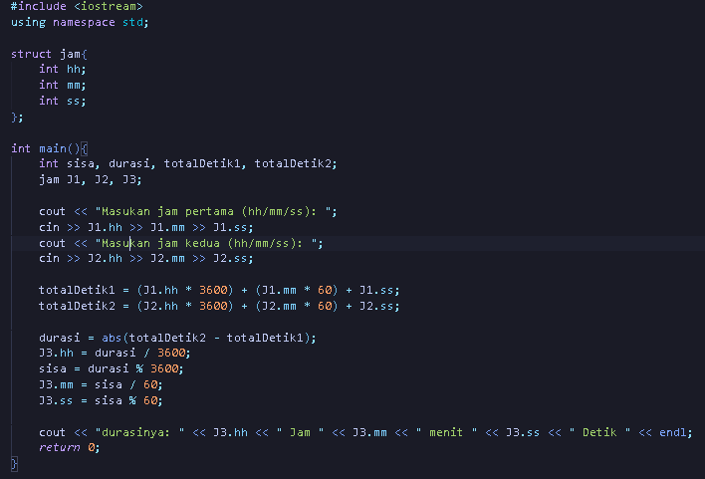

Output:



Soal 6.7

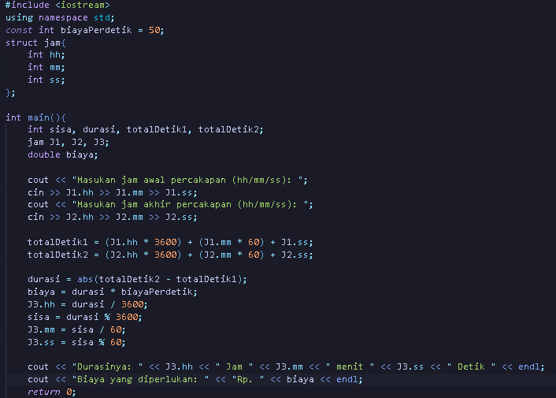

Output:



Soal 6.8

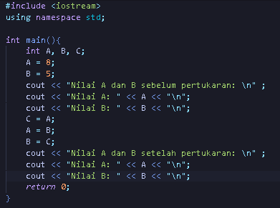

Output:

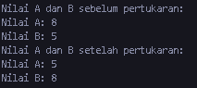

Soal 6.9

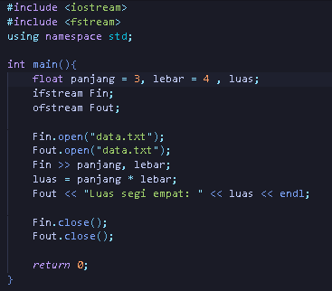

Output:



Soal 6.10

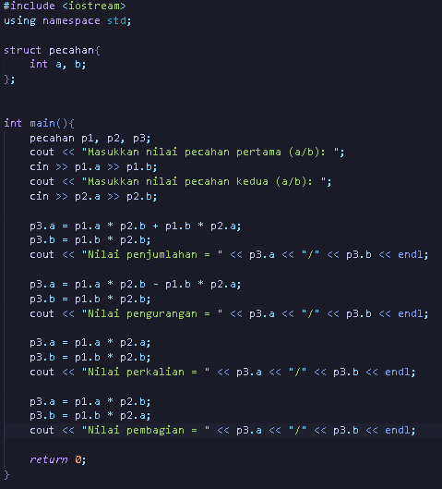

Output:

